

OpenL Tablets Reference Guide

OpenL Tablets 5.125.11
OpenL Tablets BRMS

Document number: TP_OpenL_Dev_2.4_LSh
Revised: 03-05-2014

OpenL Tablets Documentation is licensed under a Creative Commons Attribution 3.0 United States License.

Document number: TP_OpenL_Demo_2.4_LSh
Revised: 03-05-2014

OpenL Tablets Documentation is licensed under a Creative Commons Attribution 3.0 United States License.

OpenL Tablets Demo Project
This section describes complete OpenL Tablets Demo package which contains configured and ready to demonstrate infrastructure for OpenL Tablets product. The Demo enables a user to develop business rules and manage business rules sets in OpenL Tablets WebStudio, and then execute these rules as Web Services ready to be used by user applications.
In order to make work with WebStudio more comfortable and quick to start, several projects are already loaded in user workspace. As a result, a user can work on projects already created from OpenL Tablets Templates or in case of necessity create their own projects via Repository in WebStudio. In addition to demonstrate usage of rules in applications, the user can also invoke rules of the preloaded project via Web Services Client application deployed in Demo package by default.
Demo package is a .zip file which the user can download from OpenL Tablets website. After unzipping this file you will see that Demo package consists of web server Apache Tomcat (version 7.0.40) with 4 web applications which are located in \apache-tomcat-7.0.40\webapps\ folder.
These applications are:
- webstudio.war
- webservice.war
- webservice-client.war
- production-repository-server.war
Note! As production-repository-server we use Jackrabbit Web Application version 2.4.4.
To start OpenL Tablets Demo, locate <unziped Demo package folder>\apache-tomcat-7.0.40\bin\startup.bat file and run it by double-click (or via console window commands).
It is actual for Windows. But there are some specifics of launching OpenL Tablets Demo under Linux. A working directory for Openl Tablets Demo is located <unziped demo package folder>\apache-tomcat-7.0.40\bin\openl-demo\. That is why after unzipping OpenL Tablets Demo zip file user should change access rights to this folder:
sudo chmod 775 -R /<unziped demo package folder>
To get more information refer to section “Deploying OpenL Tablets WebStudio” of Installation Guide document.
After successful launching you can use the following links to the applications:
Demo application | Url
Webstudio | http://localhost:8080/webstudio
Webservice | http://localhost:8080/webservice
Webservice-client | http://localhost:8080/webservice-client
Note! After starting Demo, WebStudio installation wizard doesn’t appear. WebStudio is preconfigured in single user mode. The user sees WebStudio welcome page at start.
The following sections provides more details on Demo Project work.

WebStudio in Demo Project
Note! WebStudio is preconfigured in single user mode. The user will be automatically singed in WebStudio and will see welcome page at start.

Rules Editor
Several Examples and Tutorials are already in Editing status, therefore available in Rules Editor by default. For information how to manage rules in Rules Editor, please refer to chapter “Using Rules Editor” of WebStudio User Guide).
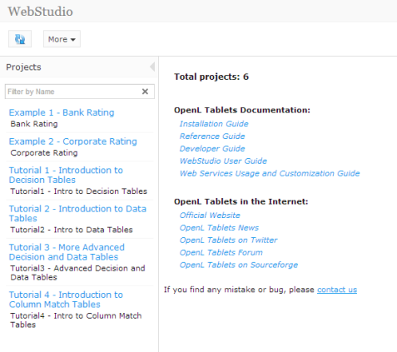
Figure 1: Projects in Rules Editor available for editing

Repository Editor
For details how to manage projects in Repository, see chapter “Using Repository Editor” of WebStudio User Guide.
The user can work with projects loaded in Repository in Demo package as well as create a new projects on his own.
There is one “Example 3 - Auto Policy Calculation” project already deployed using Deploy configuration “Example 3 - Auto Policy Calculation” to use it via Web Services in Web Services Client.
As WebStudio is preconfigured in single user mode, all projects in Repository are created/modified by ‘DEFAULT’ user.

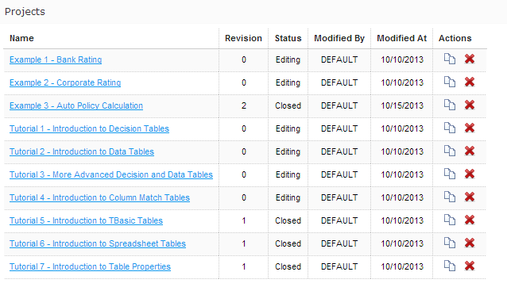
Figure 1: The whole list of rules projects in Repository of Demo Project

Administration
By default User Workspace, History and Design Repository are configured as local and located in openl-demo folder of directory <unziped demo package folder>\apache-tomcat-7.0.40\bin\. This setting is made in order to simplify configuration and usage of Demo package. It should be noted that the user can change default directory to another one (How to do it, read in WebStudio User Guide “Managing system settings”).
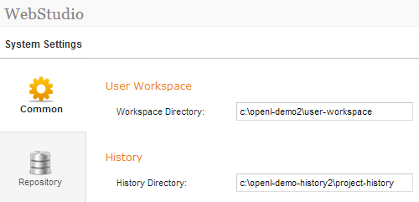
Figure 3: Common system settings in Administration
Production Repository is set to use Remote – RMI connection. An appropriate URL (//localhost:1099/production-repository) is configured by default and defined in WebStudio rules-production.properties file in folder <unzipped demo package folder>\apache-tomcat-7.0.40\webapps\webstudio\WEB-INF\conf\.
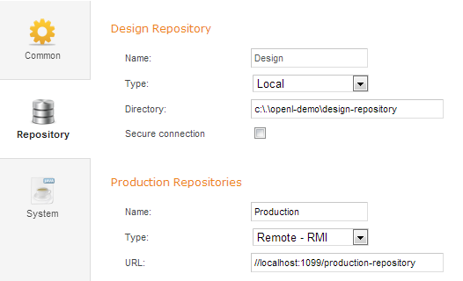
Figure 4: Settings of Design and Production repositories in Administration

Web Services in Demo Project
By default project from Template - “Example 3 – Auto Policy Calculation” is deployed to Production Repository.
In order to use this project as illustrative example of project deployments in Web Services Client, several settings are defined in Rules Configuration of the project. It is set up that only *DriverRisk*, *DriverAgeType*, *AccidentPremium* (draw your attention that here are wildcards) rules are included and can be used from Web Services Client application.
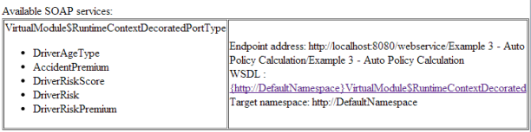
Figure 5: Web Services main page and deployed project on it.
The demo doesn’t restrict any deployments of other projects or has any other limitations so the user can deploy his own projects in Demo setup. If users deploys anything else the full list of deployed projects will appear on this page including the user’s ones.

Web Services Client in Demo Package
Web Services Client application is an application specially created to demonstrate usage of OpenL Tablets rules via Web Services application. Web Services Client is very simple application and should be used just to check that rules are easily accessible from other applications via web services.
Note! This Client invokes only several methods of particular pre deployed project “Example 3 – Auto Policy Calculation”. It means that other projects deployed by the user can not be used from within Web Services Client application.
Web Services Client application allows the user to define driver type by his age and gender, get Premium per accident or determine how risky a driver is according to Business Rules specified in the project (“Example 3 - Auto Policy Calculation”).
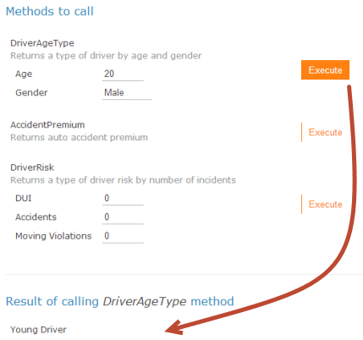
Figure 6: Executing DriverAgeType rule and getting result via Web Services Client.

The user can change the values of input parameters in fields and click the Execute button. The corresponding result will be displayed right below the list of rules to call.

OpenL Tablets Demo as common deployment pattern
The easiest way to get introduced how to use OpenL Tablets rules as Web Services in your application is to explore OpenL Tablets Demo package. This Demo configuration represents general usage scenario of OpenL Tablets product.

In short, common deployment scenario is:
- deploy Web Services application, WebStudio application and Rules Repository application (jackrabbit JCR) into web server;
- make proper configurations for JCR (jackrabbit settings), repository configurations in WebStudio and Web Services application (insure 'production' repository is configured the same way in both applications; see configurations in Demo);
- put preinitialized rules repository on your file system (jackrabbit repository according to settings for JCR);
- run web server (insure JCR application starts first).

Note! Preinitilized jackrabbit repository is required because jackrabbit cannot initialize repository in remote mode. As option, you can run WebStudio with jackrabbit configured as local and take fresh repository it creates.

